**Sprint Plan - CSE 115 – Software Methodology**

* **Heading**:

Product name：iHealthy

Team name：iHealthy

Sprint completion date：10/9/19

|  |  |  |  |
| --- | --- | --- | --- |
| Document | Revision number | Revision date | Revision member |
| Sprint 1 Plan | v1.0 | 10/9/19 | Rickie Huang,  Tommy Yang |

* **Goal:** The goal of sprint 1 is to let users click the icon and take pictures. In addition, the users are able to search the name of medicine. The developers need to manage the structure of database.
* **Task listing: sprint 1**
* User Story 1: As a user, I need to be able to click the icon and take pictures.
  + Task 1: front-end development(3 hours)
  + Task 2: call mobile’s camera(3 hours)
  + Task 3: product design(2 hours)
  + Total for user story 1: 8 hours
* User Story 2: As a user, I need to be able to type the name of the medicine and search for it.
  + Task 1: Front-end development(3 hours)
  + Task 2: product design(2 hours)
  + Total for user story 2: 5 hours
* User Story 3: As a developer, I need to be able to complete the structure of database.
  + Task 1: create a new database(1 hours)
  + Task 2: design tables(5 hours)
  + Total for user story 3: 6 hours
* **Team roles**
  + Zhijun(Tommy) Yang (Scrum Master, UI designer, developer)
  + HeQiang(Rickie) Huang (Product Owner, product manager, database administrator, developer)
  + Connor Dawson(TBD, developer)
  + Billy Kwong(TBD, developer)
* **Initial task assignment**
  + Zhijun(Tommy) Yang:
    - User Story 1:front-end development & call mobile’s camera
  + HeQiang(Rickie) Huang:
    - User Story 1&2: product design
    - User Story 3: create database & tables
  + Connor Dawson:
    - TBD
  + Billy Kwong:
    - TBD
* **Initial burnup chart**

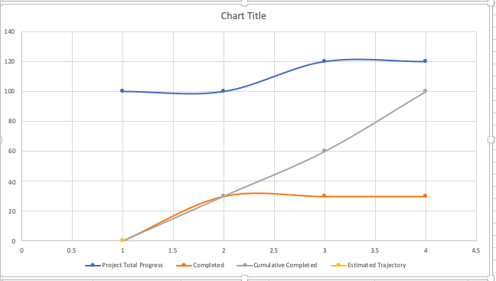

* **Initial scrum board**

|  |  |  |  |  |
| --- | --- | --- | --- | --- |
| sprint  Backlog | design | development | testing | done |
| User Story 1 | User Story 1 |  |  |  |
| User Story 2 | User Story 2 |  |  |  |
| User Story 3 | User Story 3 |  |  |  |

* **Scrum times**

TBD

HeQiang(Rickie) Huang (Product Owner)

Zhijun(Tommy) Yang (Scrum Master)

Connor Dawson

Billy Kwong

HeQiang(Rickie) Huang (Product Owner)

Zhijun(Tommy) Yang (Scrum Master)

Connor Dawson

Billy Kwong

HeQiang(Rickie) Huang (Product Owner)

Zhijun(Tommy) Yang (Scrum Master)

Connor Dawson

Billy Kwong